Table Tennis Summer League held at Pontefract Squash Club

We would like to invite all players to take part in the inaugural Table Tennis Summer League held at Pontefract Squash Club. The competition will run throughout June and July on a Friday night and matches will start at 7:15pm, finishing before 9:00pm. Matches will take place every fortnight.
Please see the rules below and if you have any further questions, please contact Chris Parker on 07957204602 or chris.parker@ackworthschool.com

- Teams of two players, but squads can be as big as you wish.
- Matches to be played fortnightly on a Friday night.
- Format – A v Y, B v Z, Doubles, B v Y, A v Z.
- Cost is £20 per team. Roughly £2 per person per night!
- Competition to begin around 1st June (depending on number of entrants) – finishing by the end of July.
- Closing date 23rd May.
- Matches start at 7:15pm (venue available from 6:45) and will be finished before 9:00pm.
- Please enter your ranking points (if known from 365 website), you will have them if you play local league. This will help us put into divisions, depending on the number of teams. If you are unsure, please enter your local league and division.
- For more information or to enter a team, please contact chris.parker@ackworthschool.com
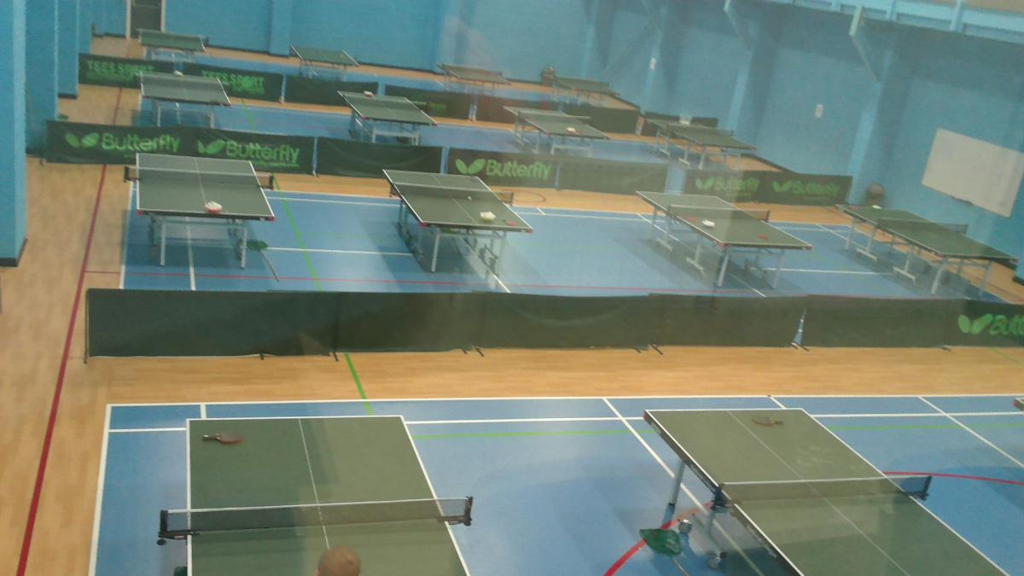
TABLE TENNIS SUMMER LEAGUE 2018 held at PONTEFRACT SQUASH CLUB REGISTRATION FORM – 2 PLAYER TEAMS
Complete the following registration form fully in order to enter the summer league. The information collected on this for will be used solely to administer this competition and will be destroyed at it’s conclusion.

Team Name:
Team Secretary:
Email Address:
Telephone Number:
Player 1 Name: |  | Email: |  | Ranking:
Player 2 Name: |  | Email: |  | Ranking:
Player 3 Name: |  | Email: |  | Ranking:
Player 4 Name: |  | Email: |  | Ranking:
Player 5 Name: |  | Email: |  | Ranking:

- Entry fee is £20.
- Matches will start at 7:15 prompt.
- Entries on first come, first in basis.
- Teams are 2 players per night but squads as big as you want.
- Format – A v Y, B v Z, Doubles, B v Y, A v Z.
- Please entry ranking from your local 365 website to help with divisions or if you are unsure, please enter your local league and division.
- For more information or to enter a team, please contact chris.parker@ackworthschool.com
- Closing date 23rd May 2018.

