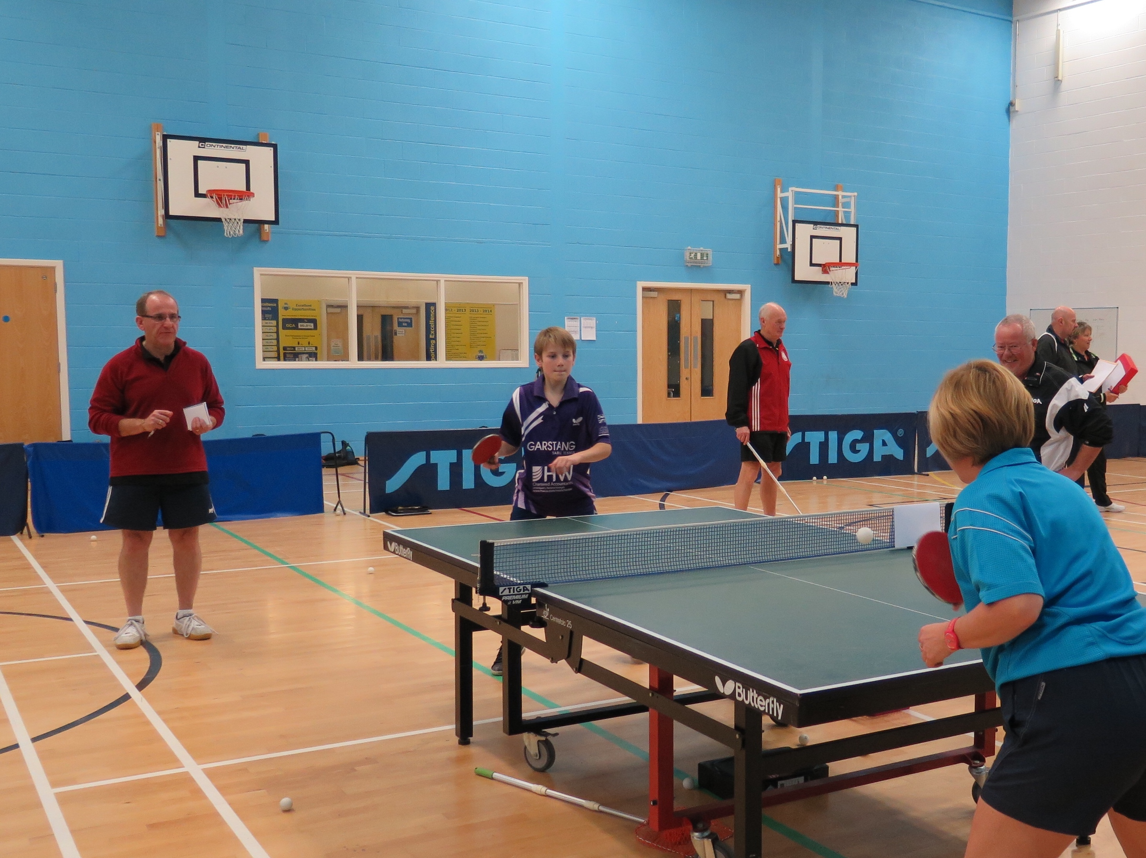  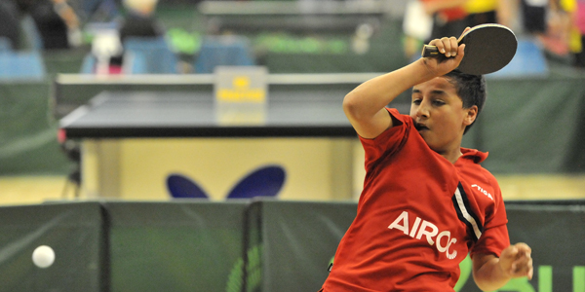  17 January 2016 - eis, sheffield  6 february 2016 - anfield ttc, liverpool  13 march 2016 - bishop auckland TTc  Northern area coach cpd WORKSHOPS  A Coach Education workshop is a fantastic way to update and refresh your coaching skills and knowledge. It is an opportunity to see new ideas, network and share ‘best practice’.   |  | Topic:  Delivering Engaging Sessions –  Adapt your sessions for schools, social and club players  Refresh your coaching skills and knowledge!  See some new ideas and share best practice!  Network with other coaches and clubs!  FREE to licensed coaches  (£10 to non-licensed)  Table tennis england  Norfolk House, 88 Saxon Gate West, Milton Keynes, Bucks, MK9 2DL  www.tabletennisengland.co.uk  www.facebook.com  /tabletennisenglandnorth

Northern area coach

cpd WORKSHOPS

To book a place on the course please return this form via email or post to:
Sally Shutt - Table Tennis England - North Area Coaching Development Officer sally.shutt@tabletennisengland.co.uk, 3 St Helier Grove, Baildon,
Shipley, West Yorkshire BD17 6SX

Topic
- We look at how the role of the coach can positively impact on the personal and social development of our participants and how important it is in the role of a coach to adapt sessions to their needs. Coaches working at all levels will benefit from this new approach to coaching which considers the ‘C’ System- Connection, Confidence, Character, Creativity, Caring/Compassion and Competence.

All coaches attending will receive resources from the day and CPD certificates stating the topic covered to meet current coach licensing requirements. For more information phone Sally Shutt on 07792 785738

Please note that places are limited and will be on a first come basis. A £10 fee is payable for non-licensed coaches. Please make cheques payable to Table Tennis England.
Full Name: Click here to enter text.
Coach Registration Number: Click here to enter text.
Email: Click here to enter text.
Tel/mobile: Click here to enter text.
I would like to reserve a place on the coach education day to be held on (please tick):

17th January, 10am - 1pm, EIS Sheffield, Coleridge Road, Sheffield S9 5DA
6th February, 10am – 1pm, Ian Robinson Sports Centre, 136 Liverpool Rd, Waterloo, Liverpool L23 0QP
13th March, 10am – 1pm, Bishop Auckland TTC, Woodhouse Ln, Bishop Auckland DL14 6LA
Click on the links for venue details and directions. Light refreshments (tea/coffee) will be provided.

