**Training course for new umpires**

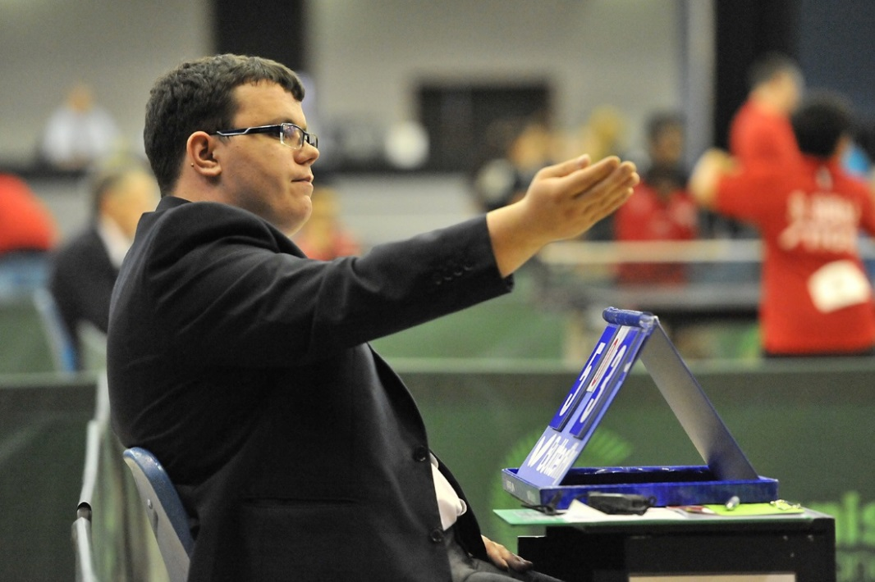Training course for new umpires

**To book places please return the form below by email to Holly Baker no later than Monday October 26th 2015.**

**Don’t hang around - only 12 places available!**

**Want to sit in the best seat in the house?**

Imagine what it would feel like to be the umpire for a final at a National Championships or better still, to umpire the top world players and on television too! Yes, this really could be you!!

Training to be a County umpire is the first step on this journey. This one day course looks at the role of an umpire; how to prepare a court for the match; check players’ equipment and clothing; match procedures; service laws; how to decide each rally as a point or a let; call and show the score correctly and learn the hand signals. Pre-course learning material/test paper will be supplied.

During the day you will assessed as an umpire and take the written test paper using reference materials. To qualify you will then need to satisfactorily complete match assessments at another approved event(s).

This course is provided **free of charge** . . . all we ask is that once you have booked a place that you attend as places are limited.

The career progression is: **COUNTY UMPIRE → NATIONAL UMPIRE → INTERNATIONAL UMPIRE**

**Sunday November 1st 2015**

**Milton Keynes**

**Milton Keynes TTC, 14 Winchester Circle, Milton Keynes, MK10 0BA**

**Application Form**

|  |  |
| --- | --- |
| **Name** |  |
| **Address** |  |
| **Postcode** |  |
| **Date of birth** |  |
| **Telephone number** |  |
| **Mobile number (in case of emergencies on the day)** |  |
| **Email address** |  |
| **Table Tennis Club / league (if any)** |  |

**Signed:** _________________________________ **Date:** ________________

Please scan / copy and return the form to Holly Baker:

Table Tennis England, Norfolk House, Saxon Gate West, Milton Keynes. MK9 2DL

OR email: [holly.baker@tabletennisengland.co.uk](mailto:holly.baker@tabletennisengland.co.uk)

Any questions, please call Holly on 01908 208891

**Closing date: Monday 26th October 2015**