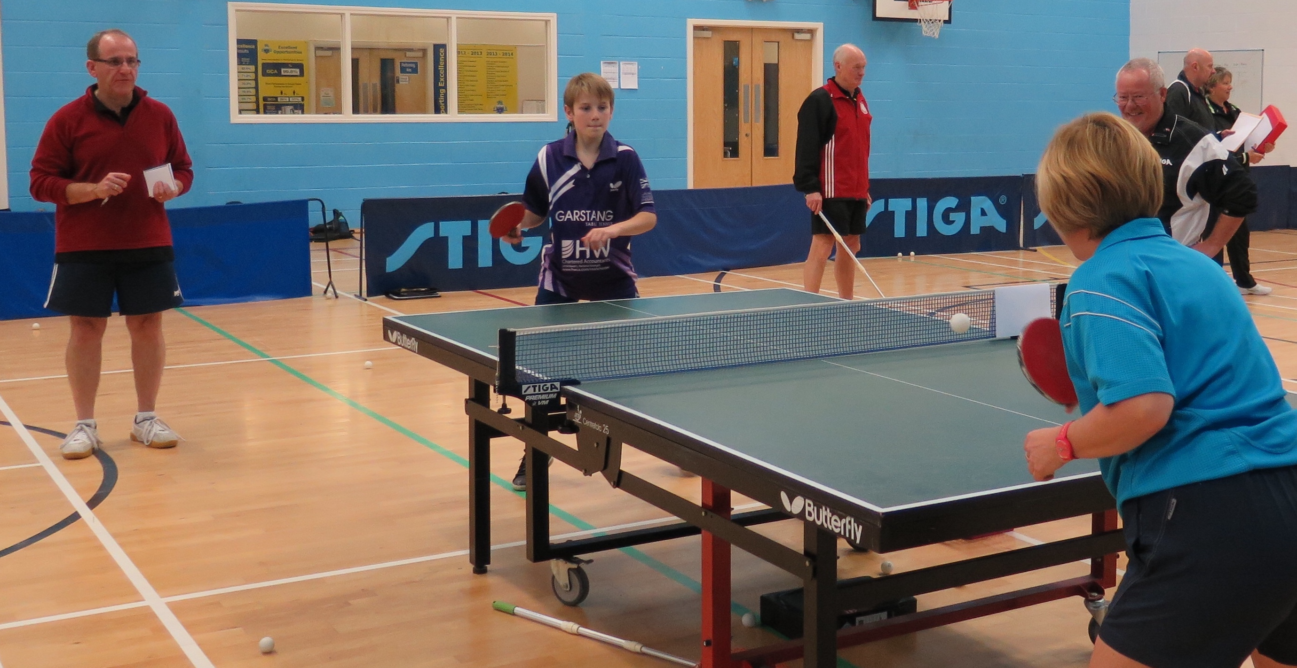  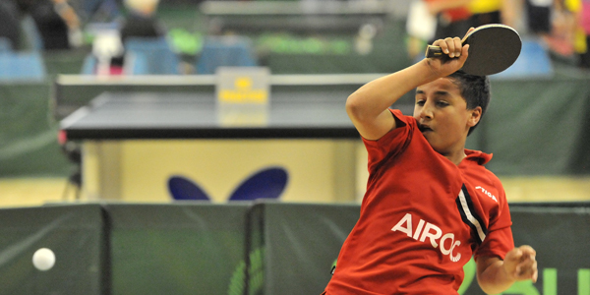  Saturday 22 AUGUST 2015, UCLAN, PRESTON (AS PART OF THE ENGLAND YOUTH SQUAD TRAINING CAMP)  Sunday 13 SEPTEMber 2015, KEIGHLEY ttc  Northern area coach cpd WORKSHOPS  A Coach Education workshop is a fantastic way to update and refresh your coaching skills and knowledge. It is an opportunity to see new ideas, network and share ‘best practice’. |  | Topic:  Coaching ‘The Winning Way’ - Why it is important to teach a style of play that will allow all players to reach their full potential  Refresh your coaching skills and knowledge!  See some new ideas and share best practice!  Network with other coaches and clubs!  FREE to licensed coaches  (£10 to non-licensed)  Table tennis england  Norfolk House, 88 Saxon Gate West, Milton Keynes, Bucks, MK9 2DL  www.tabletennisengland.co.uk  www.facebook.com  /tabletennisenglandnorth

Northern area coach

cpd WORKSHOPS

To book a place on the course please return this form via email or post to:
Sally Shutt - Table Tennis England - North Area Coaching Development Officer sally.shutt@tabletennisengland.co.uk, 3 St Helier Grove, Baildon,
Shipley, West Yorkshire BD17 6SX

Topic
- ‘The Winning Way’- National Head Coach Nick Jarvis is keen that coaches working at all levels understand the importance of teaching a style of play that will allow young players to develop and reach their full potential. We will analyze modern styles of play and try put this into context of your own coaching environment.

There will also be an open coaching forum and development update to discuss Table Tennis England’s new development strategies.
All coaches attending will receive resources from the day and CPD certificates stating the topic covered to meet current coach licensing requirements. For more information phone Sally Shutt on 07792 785738

Please note that places are limited and will be on a first come basis. A £10 fee is payable for non-licensed coaches. Please make cheques payable to Table Tennis England.
Full Name: Click here to enter text.
Coach Registration Number: Click here to enter text.
Email: Click here to enter text.
Tel/mobile: Click here to enter text.
I would like to reserve a place on the coach education day to be held on (please tick):

☐ Saturday 22nd August (CD 17/8/15), Sir Tom Finney Sports Centre, UCLAN, Preston PR1 2YF ☐ 10am - 1pm or ☐ 2pm - 5pm (2 courses - Please tick preferred time).
☐ Sunday 13th September (CD 7/9/15), Keighley TTC, South Street, Keighley, BD21 1SY 10am - 1pm.

